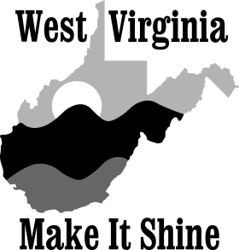
2018 West Virginia Make It Shine Statewide Cleanup
April 1-14, 2018
Registration Deadline March 9, 2018
Return to:
WV Make It Shine
601 57th Street, SE
Charleston, WV 25304
Phone: (800) 322-5530 Fax: (304) 926-0458
terry.r.carrington@wv.gov
Group name:
Contact person:
Address:
City: |  | State: |  |  | Zip:
Phone: |  | Fax:
Email:
Alternate contact person:
Address:
City: |  | State: |  |  | Zip:
Phone: |  | Fax:
Email:
County in which cleanup will occur:
Cleanup date: |  |  | Number of volunteers:
Type of project (Refer to attached information):
Resources requested (Please circle): Hauling Landfill fees Gloves and bags
Location (be specific) and a brief description of your project:
OFFICE USE ONLY | County |  | DOH | DEP

The 2018 WV Make It Shine Statewide Cleanup is sponsored by REAP within the Department of Environmental Protection and the Division of Highways. This cleanup is project oriented (refer to the information on the back page of this application to determine what types of projects qualify for assistance) and can take place any time from April 1, 2018 until April 14, 2018. Projects must be approved by our office before a group can receive assistance. The registration deadline is March 9, 2018. (Continued on back)
2018 WV Make It Shine Statewide
Cleanup Information

In order to receive assistance with your cleanup, prior approval for the project must be given by the WV Make It Shine Program.

Attention: Groups or individuals conducting unapproved cleanups will be solely responsible for the removal and disposal of waste collected.

The following types of projects qualify:

· River/stream cleanups
· Lake cleanups
· Illegal dump cleanups
· Park cleanups
· Playground cleanups
· Public cemetery cleanups
· School ground cleanups
· Miscellaneous cleanups with prior approval

The following types of projects DO NOT qualify:

· Community dump days
· Drop off sites
· Household garbage collection
· Cleanups of private property
· Adopt-A-Highway adopted roadways

Assistance available:

· Trash bags, gloves and disposal fees paid by the DEP’s PPOD program
· One day (8 hours) per dump truck, per county of hauling by the DOH to the landfill
· Public relations and press assistance

Things to remember when planning your project:

· Disposal fees will be paid directly to the landfill and only for the waste that results from the one-day cleanup project.
The waste will be hauled to a proper location at the hauler’s discretion.
· Cleanup participants are encouraged to recycle; however, you must arrange for the disposal of any recyclables collected.

