# BENTHIC MACROINVERTEBRATE COLLECTION PROTOCOLS

## Overview

### Definitions

**MACROINVERTEBRATES** - Animals that are large enough to be seen with the naked eye and do not have a backbone.

**BENTHIC ORGANISMS (or BENTHOS)** - Living organisms that reside on the bottom of streams, rivers, or lakes. Benthos may include vertebrates, invertebrates, or plants.

**KICK** - One method for collecting benthos. A hand-held net is held in the stream. The stream bed upstream of the net is disturbed using a kicking motion to dislodge the organisms, which then float into the net.

### Benthic Macroinvertebrates as Environmental Indicators

Benthic macroinvertebrates are small animals living among the sediments and stones on the bottom of streams, rivers, and lakes. Insects comprise the largest diversity of these organisms and include mayflies, stoneflies, caddisflies, beetles, midges, crane flies, dragonflies, and others. Other members of the benthic macroinvertebrate community are snails, clams, aquatic worms, and crayfish. These organisms are extremely important in the food chain of aquatic environments. They are extremely important in the food chain of aquatic environments as they are important players in the processing and cycling of nutrient and are major food sources for fish and other aquatic animals.

Benthic macroinvertebrates have been used for many years to assess water quality. Currently, they are utilized throughout the world in water quality assessments, as environmental indicators of biological integrity, to describe water quality conditions or health of aquatic ecosystems, and to identify causes of impairment. Benthic macroinvertebrate communities are known to respond to a wide array of environmental stressors, and in different ways. This response will often make it possible to determine the type of stress that has affected the community. Many macroinvertebrate taxa have relatively long life cycles. Thus, community structure is a function of past water quality conditions.

### Basis of Sampling Method

The sampling methods to be used in the WVDEP Watershed Assessment Branch (WAB) are qualitative in nature and are outlined in "Rapid Bioassessment Protocols for Use in Wadeable Rivers and Streams, Second Edition" - U.S. Environmental Protection Agency, July 1999 (EPA 841-B-99-002) (***see* Error! Reference source not found. *in*** *Error! Reference source not found.****.*** *Error! Reference source not found.****.* Error! Reference source not found.** **Error! Reference source not found. *starting on page*** *Error! Bookmark not defined.*). This protocol has been adopted for use by many states and organizations. The WAB will utilize the Single Habitat Approach when possible, using a rectangular dip net (0.5 m wide) or smaller (0.3 m wide) D-net with a 595-600 µm mesh size to sample riffle/run habitats. The Multi-habitat Approach (also called MACS, which stands for Mid-Atlantic Coastal Streams) may be used in slow-moving wetland type streams, using the smaller D-net**. It is important to note that the following protocols were established for use by the Watershed Assessment Branch monitoring programs and were intended to provide cost-effective techniques with comparable data across the state. Special projects outside of the Watershed Assessment Branch monitoring agenda (*i.e*., point source surveys, spills, large river monitoring) may not allow strict adherence to these protocols.**

The sampling protocols are listed and prioritized below:

1. Rectangular Dip Net - for riffle habitats > 0.5 meter wide
2. D-Frame Net - for riffle habitats < 0.5 meter wide
3. D-Frame Net - used in the absence of moving water (for use in low-gradient streams and glide/pool habitat – MACS or Multi-habitat Approach)
4. Hand Picking - used in very small streams where other sampling apparatus cannot be used.

These methods are described in detail in the subsequent sections.

### Selecting Sampling Sites

Predominantly, streams in West Virginia are high gradient with coarse substrate materials such as boulder, cobble, and gravel. These physical conditions are responsible for the typical riffle/run habitats commonly found in most areas of the state. WAB establishes sample sites and assessment reaches on streams based on the best available riffle/run habitat (random sites excluded). There should be at least one square meter of riffle/run habitat in the assessment reach to obtain a complete benthic macroinvertebrate sample.

It is important that the sampling method be selected based on the availability of the reference condition (riffle/run predominant for most of WV) and not of potentially impaired streams. For example, sampling decisions should not be altered for situations where the amount of cobble/gravel substrate in streams influenced by heavy sediment deposition may be substantially reduced from the amount of cobble/gravel substrate expected for the region. That is, sample sites on streams with heavy deposits of fine sediments should not be avoided if it is determined that the sedimentation is not typical of the area and has resulted from poor land-use practices. Occasionally, low gradient streams are encountered that have heavy deposits of fine sediments as a result of naturally high sedimentation rates. In this case, the Multi-habitat Approach should be employed. Currently, WAB does not conduct benthic assessments on low gradient streams unless there is a special interest for the resultant data. The decision to sample a particular stream site is field based and should be made after corroboration by WAB team members or by the most experienced person. In any event, detailed notes describing the situation should be recorded on the field form.

Another concern when locating a benthic sampling site is tributaries or sources that enter the stream within the reach and may significantly alter the water quality. It is extremely important that the benthic data collected always match the water chemistry observed and collected at the X-Site. During the site selection and planning that occurs in the office, every effort is made to try to avoid such situations by locating the site above tributaries and known sources. However, occasionally sources are unknown or moving the site is not possible (*e.g.*, randomly selected sites). The most important thing to do is to always inspect the sample area as thoroughly as possible prior to beginning the benthic collection. Some things to look for are:

1. Significant change in water chemistry (*i.e.*, pH, conductivity, DO, Temperature) from above the source to below the source.
2. Visual indicators that the tributary or source has a significant impact on the mainstem area downstream (*e.g.*, sudden appearance of hydroxides, oils, grease, etc. below the tributary or source).
3. In larger streams, pluming of water chemistry along one bank due to an inadequate mixing zone in the mainstem.

In such cases, the entirety of the benthic kicks should be located either above or below the source. Unfortunately, outside of specific directions on the field list, there is little in the way of guidelines on picking one or the other and the samplers must rely on best professional judgment. In the case of a randomly selected site where the X-site is located below a source or tributary with a significant water quality impact to the stream and there is inadequate room to collect benthos in the area below the source, it would be best to treat the source or tributary with significant water chemistry issues using the same rules as sliding the reach downstream around the X-site to avoid crossing stream orders (***see*** *Error! Reference source not found.****.*** *Error! Reference source not found.****.* Error! Reference source not found.Error! Reference source not found. *starting on page*** *Error! Bookmark not defined.*) so that the X-site and benthic collection area are in similar water quality.

Before sampling begins, a 100-meter assessment reach is established containing the X-site (usually located at the downstream terminus of the reach). All assessment activities are conducted within this designated reach including the collection of water samples, benthic macroinvertebrate samples, and habitat assessments. The benthic collector should select sampling points with the intent to make collections throughout the entire 100 meters in a diversity of the best available habitats. For example, look for varying conditions within the reach such as fast and slow riffle/runs, deep and shallow riffle/runs, shaded and exposed riffle/runs, and sample from the best available in each observed. In some instances, the best available habitat (*e.g.*, riffle) may be limited to a small area within the reach. In this case, collections should be made within those areas only. However, if riffle areas occur throughout the 100-meter reach, an effort should be made to collect from as many different points within the reach as possible. It is important to sample the diversity of riffle/run conditions if they exist.

The various habitat types that may be encountered are defined as follows:

**Pool** - Still water with low velocity. Water surface is smooth and glassy. Usually deep compared to other parts of the channel.

**Glide** - Slow moving water with a smooth, unbroken surface. Turbulence is low. Usually shallow compared to other parts of the channel.

**Run** – Similar to glide but water is moving slightly faster. Turbulence is low and the surface is without ripples that produce gurgling sounds. Runs may have small waves.

**Riffle** - Water moving with small ripples, waves and eddies. Produced a babbling or gurgling sound.

**Snag** - Submerged woody debris (logs, root wads, etc.).

**Submerged Macrophytes** - Aquatic vegetation growing beneath the water surface.

**Vegetated and Undercut Banks** - Stream banks having submerged vegetation (shrubs, etc.) and/or root wads.

## net sizes1mBenthic Macroinvertebrate Sampling

### Materials and Reagents

***See Figure 42 & Figure 43 for Diagrams & Picture of most of these materials.***

1. Rectangular Frame Dip Net – A net with a 0.5 m wide and 0.3 m high frame with 595-600 µm mesh openings and 0.5 m nylon bag attached to a four foot pole will be used to collect benthic macroinvertebrates in riffles and runs.
2. D-Frame Dip Net - A D-frame (D-net) aquatic dip net with 595-600 µm mesh openings and 1 ft. nylon bag will be used to sample streams that are too small to be sampled using the rectangular frame dip net.

Figure 1. Diagram comparing the dimensions and number of kicks necessary to sample 1 m2 of a Rectangular Frame Dip Net versus a D-Frame Dip Net

1. Five-gallon bucket - to composite kick samples in the field.
2. 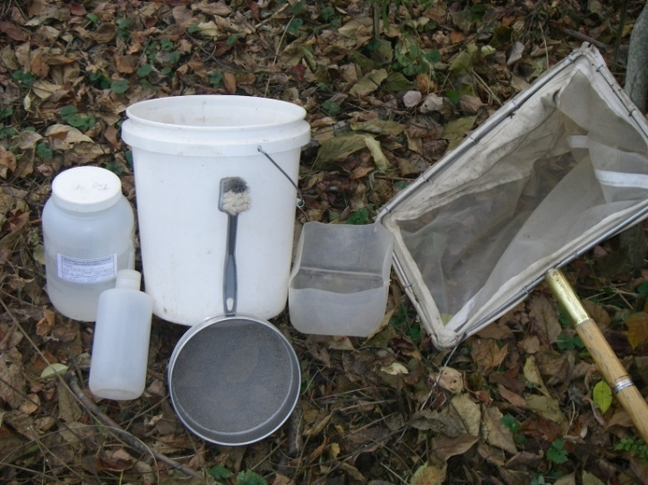30 mesh sieve (600 µm) - to remove small particulates and water from samples.
3. Small dish washing scrub brush – aid in removing macroinvertebrates from stream substrate particles such as cobble and cleaning the net.
4. Small plastic container or tray – to temporarily hold the organic materials and elutriate.
5. Gallon-sized sample jars - containers to hold benthic sample and associated debris.
6. Inside and outside labels - for sample identification and tracking.

Figure 2. Photo of Materials used in Benthic Macroinvertebrate Sampling

1. Fine-tipped forceps – for removing organisms from net or sieve.
2. One liter squirt bottle – for washing benthic organisms from the bucket, sieve, and elutriate container.
3. 95% Denatured ethanol - for preservation of benthic macroinvertebrates.
4. Ice chest / cooler - for the storage of samples during transport.
5. Sample log book - for tracking the locations of the biological samples.
6. Scientific collecting permit – Obtained yearly by Watershed Assessment Branch from the WVDNR.

### Field Safety Precautions

Rubber gloves and protective eyewear should be worn during sample collection to avoid bacterial contamination and for personal health protection as many streams may have sharp objects embedded in the substrate (*e.g.*, glass, metal, wire, etc.). They should also be worn during sample preservation or at any time while handling alcohol, which can be a skin irritant and can cause damage to the eyes.

### Sample Collection Methods

Before any benthic sampling event:

* Fill out a pre-printed sample label with a No. 2 pencil. Attach to the outside of the sample jar using clear, waterproof tape. Fill out a pre-printed sample label made of waterproof paper for the inside of the sample jar. Some place the inside label inside the jar before the sample is collected; others do so after the sample is collected. **Just make sure that the inside label gets inside the jar.**
* Fill the sample jar ½ full with 95% denatured ethanol.
* If using a net, check the net to ensure there are no holes or benthic remnants of previous samples. If there are holes or tears in the net, it should be repaired immediately before the next sample is collected and/or replaced as soon as possible.
* Wash the net in the stream to ensure that there are no benthic remnants of previous samples.

#### Training 2005 024Rectangular Dip Net (Riffle/Run Habitats = Comparable)

This method is used in streams having riffle/run habitat and a width > 0.5 meter. This method is to be used even when there is no cobble substrate in the riffle/run area. If the stream has enough flow to wash benthic macroinvertebrates into the net this is the method to use.

1. Select a riffle/run area to sample. Position the net on the stream bottom so as to eliminate gaps under the frame with the net opening upstream. Large rocks or logs that prevent the net from seating properly should be avoided (***see Figure 44 on right***).

Figure 3. Photo of Rectangular Frame Dip Net being placed on stream bottom

1. 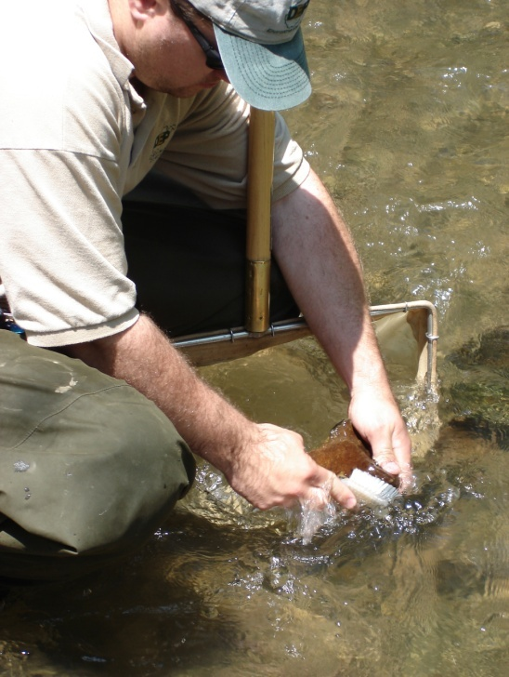Hold the sampler in position on the substrate while checking for heavy organisms such as clams and snails in an area of about 0.25 m2 (0.5m wide net x 0.5m upstream) in front of the net. Hand-pick these organisms and place them in the net or the bucket if placed nearby. Do not collect large freshwater mussels! Some mussel species are endangered and should not be disturbed. Record their presence on the field form and identify them if possible.
2. Brush the surfaces of all coarse gravel, cobble, boulder, and bedrock substrate (***see Figure 45***). If the substrate is removable, pull it up and hold it underwater in front of the center of the net while brushing all surfaces so that dislodged organisms flow into the net. Cleaned substrate should then be set aside. In low flow situations, these rocks can be placed at the edge of the net in a manner that increases the amount of water flowing through the net. Large substrate that is partially in the kick sample area should only be brushed on that portion which resides in the 0.25 m2 kick area.

Figure 4. Photograph of the Brushing process in front of the net.

1. 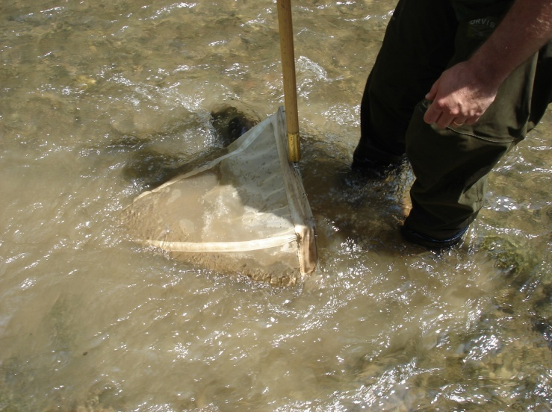Hold the net handle securely while kicking the substrate vigorously for 20 seconds to a depth of 10 cm in an area of about 0.25 m2 (0.5m wide net x 0.5m upstream) in front of the net (***see Figure 46***). At this time it may be possible to remove large objects (*e.g.*, cobble, large gravel) from the net while the water is still sweeping through the net.

Figure 5. Photograph of the Kicking process in front of the net.

1. 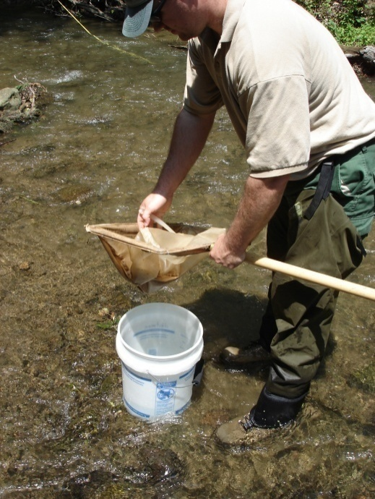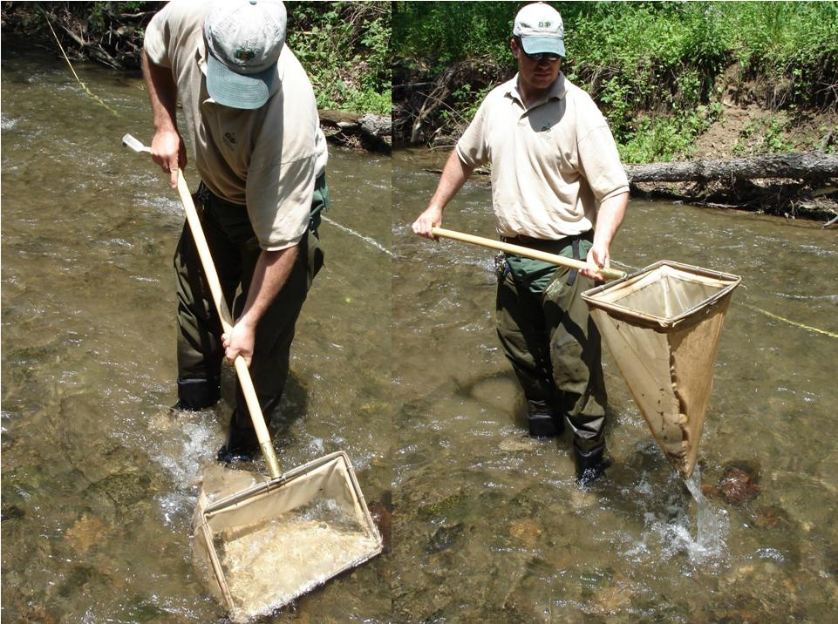Remove the net from the water with a quick upstream motion to wash the organisms to the bottom of the net (***see Figure 47***). Empty the contents of the net into a five gallon bucket that is partially filled with water (***see Figure 48***). Emptying the net after each kick sample is recommended because debris can clog the net mesh causing reduced flow- through and back eddies, both of which can result in the loss of organisms. It is not necessary to fine pick every last item from the net at this point, just the get the bulk of the sample into the bucket.

Figure 6. Photographs showing the removal of the net from the water with an upstream motion.

1. Repeat this process until 4 riffle/run habitats have been sampled. This will result in 4 individual kick samples that cover approximately 1 m2 (4 x 0.25 m2) of stream substrate. The 4 kick samples will be composited into 1 sample. If a diversity (fast and slow – stacked and flat, etc.) of riffle/run types is not present, collect the 4 samples from the best available habitat. It is important to obtain 4 kick samples for the composite. Always record the type and number of each riffle/run sampled on the field assessment form.

Figure 7. Photograph of Emptying the net into a 5- Gallon bucket partially filled with stream water.

**Note: The RBP protocol (EPA 841-B-99-002) suggests that 2 square meters of substrate should be sampled and composited at a given site. WAB determined through analysis of duplicate data (2 m2 versus 1 m2) and consultation with EPA Region III biologists that a 1 square meter sample is adequate for characterizing riffle/run streams in West Virginia where the West Virginia Stream Condition Index is to be used for impairment classification.**

1. Inspect the net for clinging organisms. Using a pair of small forceps, remove all the remaining organisms and place them in the bucket.
2. After compositing all four kicks into the bucket, all large objects (rocks, sticks, leaves, etc.) should be carefully washed, inspected for organisms, and discarded (***see Figure 49***). It is very important to remove as much rough material as possible without losing organisms. This will reduce laboratory 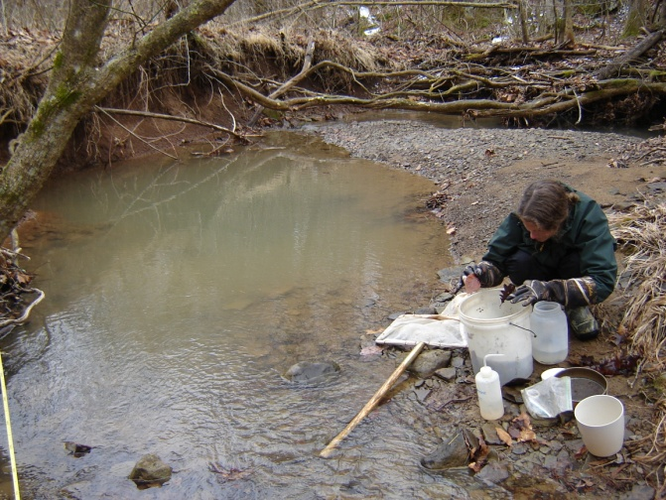sorting time and limit the crushing and grinding that damages benthic specimens. However, if there is an excess of leaves in the sample, this step may become too time intensive to pursue beyond a cursory sorting and removal of the leaves. You can base the amount of time to spend with this by estimating how much longer your partner needs to finish the habitat assessment.

Figure 8. Photograph of Biologist inspecting benthic sample and removing rough material (rocks, sticks, and leaves)

1. 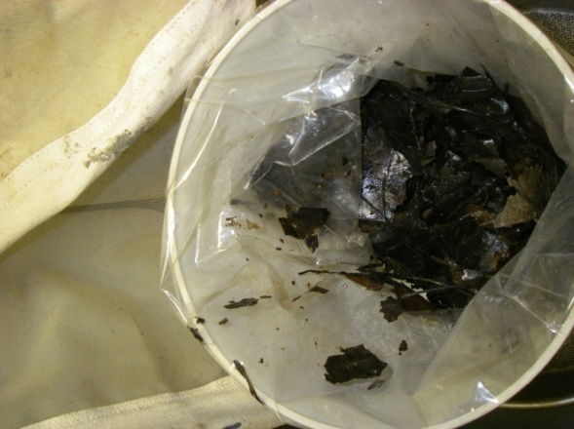Elutriate the bucket’s soft, organic material (bugs, leaves, CPOM) by using a stirring or swirling motion. Begin pouring some of the elutriated organic material into U.S. Standard 30 sieve. Using a quiet area of the stream or fresh water in the bucket, gently touch the bottom of the sieve to the water surface and rotate it in a circular motion. This will aid in removing fine sediments from the sample.Transfer this material from the sieve into a temporary container (*e.* *g.*, another bucket, a tray, another sample jar) (***see Figure 50***). Repeat this process until almost all of the organic material is removed from the bucket. If possible, release any fish and/or salamanders and document the species and number released in the Wildlife Observations section of the Habitat Form. Set the container of elutriated material aside.

Figure 9. Photograph of soft, organic material placed and stored in a temporary container.

1. Begin the elutriation process again with the inorganic material (gravel, sand, silt). Pour some of the contents of the bucket through a U.S. Standard 30 sieve. Too much material in the sieve may result in accidental spillage.

1. 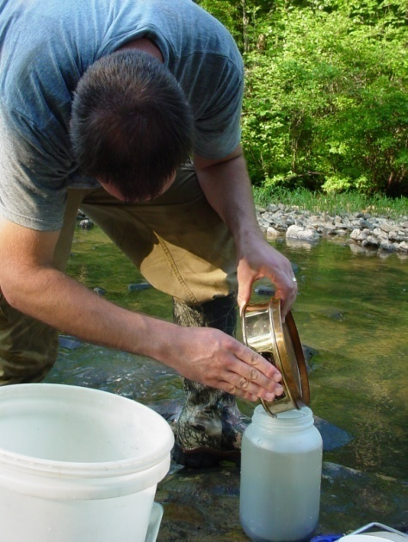Using a quiet area of the stream or fresh water in the bucket, gently touch the bottom of the sieve to the water surface and rotate it in a circular motion. This will aid in removing fine sediments from the sample. **DO NOT IMMERSE THE SIEVE ENTIRELY AS THIS WILL RESULT IN THE LOSS OF ORGANISMS.** If possible, release all fish and salamanders and document the species and number released in the Wildlife Observations section of the Habitat Form.
2. Pour the hard, inorganic material such as fine gravel and sand from the sieve into a sample jar already 1/2 filled with denatured ethanol (***see Figure 51***). Repeat Steps 9-11 until all of the inorganic material is sieved and placed into the sample jar. Using a squirt bottle filled with stream water, rinse any remaining material from the bucket onto the sieve.

Figure 10. Photograph of Biologist transferring the hard, inorganic material (e.g., fine gravel, sand, and silt) to a sample jar ½ filled with alcohol.

1. 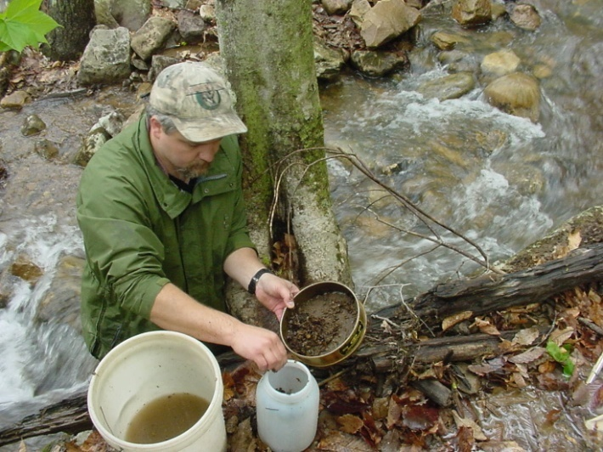Use the squirt bottle to aid in removing remnants of the sample from the sieve, but avoid getting large amounts of water in the sample jar, as this will dilute the preservative. Inspect the sieve carefully for any remaining organisms and place them in the sample jar.
2. Return to the elutriated soft, organic material (bugs, leaves, CPOM) that was set aside earlier from Step 9. Using a quiet area of the stream or fresh water in the bucket, gently touch the bottom of the sieve to the water surface and rotate it in a circular motion. This will aid in removing fine sediments from the sample. Once all of the fine sediments are thoroughly removed, place the elutriated organic contents in the sieve on top of the inorganic material (gravel, sand, silt) previously in the sample jar as in Step 12 (***see Figure 52 above***). Placing the elutriated material on top in the sample jar will protect the often fragile benthic organisms from damage due to grinding and compaction during transport to the laboratory. Do not invert or shake the sample jar after the elutriated materials are placed inside.

Figure 11. Photograph of Biologist inspecting transferring the soft, organic material (e.g., shredded leaves and benthic organisms) to the sample jar.

#### D-net (Riffle/Run Habitat = Comparable)

In some situations the stream may be too narrow or shallow to sample using a Rectangular Dip Net. In this case, a D-net will be substituted for sample collection. The methods outlined for the Rectangular Dip Net are applicable when using the D-net in riffle/run streams. The only modification is an increase in the number of kick samples to be collected. This change is necessary to sample approximately the same area (1 square meter). Since the D-net is ≈ 0.33 m wide, we will sample a square area in front of the net of 0.1108 m2 (0.333m x 0.333m). In order to sample 1 m2, we need to collect from 9 locations (0.1108 m2 x 9 = 0.9972 m2).

#### D-net – Multi-habitat Approach (Low Gradient Streams, Glide/Pool Habitat=Non-Comparable)

The RBP procedures described above are only applicable to flowing, wadeable streams. The Multi-habitat Approach is based on protocols developed by the Mid-Atlantic Coastal Streams (MACS) Workgroup, which are employed in low gradient, slow moving streams. **This method is to be used only in wetland type habitat where flow is insufficient to move suspended materials into a net.**

Note: This type of sampling is considered non-comparable at this time as the majority of other samples taken by the Watershed Assessment Branch and analyzed using the WVSCI (West Virginia Stream Condition Index). Therefore, it should only be used for special surveys/projects or if specifically specified in the sampling plan/instructions.

1. Determine the types of productive habitat to be sampled and the percentage of each habitat within the sample station. Productive habitats are snags, vegetated banks, and submerged macrophytes. A total of 20 jab-sweeps (see next step) are collected based on the proportion of productive habitats available in the 100-meter assessment area. For example, if 50% of the habitat is snag material and 50% is submerged macrophytes, then 10 jab-sweeps (50%) are taken in snags and 10 jab-sweeps (50%) are taken in submerged macrophytes. If a particular type of habitat is rare (<5%), it is not sampled.
2. Collect macroinvertebrates by jab-sweeping the net into productive and stable habitat. A "jab-sweep" is an aggressive thrusting and sweeping of the net into productive habitat for a distance of one half meter. **Make only one jab-sweep; resist the urge to re-sweep!** A total of 20 jab-sweeps will be combined to complete the sample. The precise jab-sweep technique will vary with the type of habitat being sampled.
   1. **Snags**–Disturb the snag area first by kicking it to dislodge the organisms. Then quickly jab-sweep the net into small sticks and branches or scrape the net along the lower surface of logs. Medium sized snag material is best –sticks and branches. Large logs should be avoided because they are generally difficult to sample adequately.
   2. **Submerged Macrophytes** - In deep water, drag the net through the vegetation from the bottom to the water surface (maximum of 0.5 m each jab). In shallow water, bump the net along the stream bottom within the macrophyte bed, avoiding sediments where possible.
   3. **Vegetated and Undercut Banks** - Use the snag collection method for collecting from roots and emergent plants that are on the lower banks of streams. Submerged areas of undercut banks are included here. Sample unvegetated banks by bumping the net along the substrate.
3. After five jab-sweeps have been collected, empty the net into a 5-gallon bucket containing stream water. (The net may be emptied more frequently, depending on the amount of material.) Repeat until 20 jab-sweeps have been collected.

The remaining procedure is the same as for the Rectangular Dip Net. Follow steps 8 through 14 under Sample Collection Methods – I. Rectangular Dip Net (Riffle/Run Habitats = Comparable) to complete field processing and preservation.

#### Hand Picking (Small narrow streams with minimal/interstitial flow = Non-Comparable)

This sampling method should only be used for special surveys/projects or if specifically specified in the sampling plan/instructions as it is considered non-comparable to other samples. This method should be used in very shallow low-flow situations where there is not enough water to flow over the lip of the Rectangular Dip Net or D-net. Do not collect a sample if there is no interstitial flow in the areas between pools.

1. Sample in areas that would be considered riffles in higher flows. Do not sample in pool habitat. Pick up rocks (small gravel to small boulder) from about 0.25 m2 (same area as that would be sampled by the Rectangular Dip Net) of substrate. Rub and rinse the rocks into a 5 gallon bucket partially filled with water. Repeat this procedure at four different areas - looking for the best habitats (highest interstitial water flow and most cobble sized rocks).
2. Use the rocks sampled to complete the benthic substrate section of the Habitat Assessment Form.
3. Pour the entire contents of the bucket through a U.S. Standard 30 sieve. Using a squirt bottle, rinse any remaining organisms from the bucket onto the sieve. Using forceps, remove any remaining organisms and transfer to jar. Place sample jar in cooler or other air-tight container designated for benthic macroinvertebrates.

The remaining procedure is the same as for the Rectangular Dip Net. Follow steps 8 through 14 under Sample Collection Methods – I. Rectangular Dip Net (Riffle/Run Habitats = Comparable) to complete field processing and preservation.

### Sample Preservation Methods

* 1. Fill a gallon sized sample jar about 75% full with 95% denatured ethanol. The goal is to reach a concentration of ethanol near 70% after the sample and some water has been added. If there is a small amount of water and organic material in the sample, it may not be necessary to fill the jar to 75% capacity to reach a 70% concentration. It is important that sufficient ethanol be used to reach 70% concentration. In addition, enough alcohol should be added to at least immerse all of the material in the jar. If more ethanol is needed, it can be added after the sample is received at the laboratory.
  2. Make sure that there is a waterproof label filled out with pencil inside the jar and a label affixed to the outside of the jar using clear packing tape. Include stream name, AN-Code, and date on both labels. Place the jar in a cooler or other container designated for the storage and transport of benthic macroinvertebrate samples to the laboratory.
  3. Avoid agitating the sample jars as much as possible. Do not invert the jars.

### Laboratory Documentation or Check-In

Upon return to the office, all samples are to be logged into a Benthic Macroinvertebrate Sample Logbook. Each entry is to include: Date of Collection, date received by office, stream name, Random number (if applicable), AN-Code, and collector's initials. If a sample is in multiple jars, each jar is entered individually and designated as "1 of 2" or "2 of 2", as appropriate.

### Benthic Sampling Quality Assurance/Quality Control

Sample labels are to be accurate and complete and contain all the information discussed above. Sample equipment will be checked for residual benthic material, rubbed clean and thoroughly rinsed with stream water before and after each sampling event.

Duplicate samples will be collected from 2.5% of the sites sampled and only when at least two people are on a sampling team. Benthic macroinvertebrates will be collected along with other activities at the designated duplicate WAB sites. Both duplicates are collected at the same date and approximate time (as equipment sharing will allow) by different individuals. Extreme care is taken to assure that the second duplicate is not taken from an area that may have been depleted by the first duplicate. The duplicate data will be analyzed to ensure precision and repeatability of the sampling technique. Every effort is made to assure that different teams perform the duplicate sampling throughout the sampling season to ensure that all variability is being captured. The variances between individual techniques will be documented and used in future training sessions or individual re-training. In addition the duplicate data is looked at by Watershed Assessment Branch staff and scrutinized to find any possible discrepancies, contamination, or faults in the sampling methods and techniques. Any problems are brought to the attention of the program management and steps are made to immediately correct the problem. Data that is related to the problem are flagged with notes concerning the details of the situation so that decisions can be made whether or not to include the data in any further assessments or analysis. ***See*** *Error! Reference source not found.****.*** *Error! Reference source not found.****.* Error! Reference source not found. *starting on page*** *Error! Bookmark not defined.* ***for additional information.***

Once a year, all field participants in the WAB attend mandatory training sessions in March-April prior to the initiation of the major sampling season. The purpose of these sessions is to ensure that all field personnel are familiar with sampling protocols and calibrated to sampling standards. A hands-on session concerning the collection and handling of benthic macroinvertebrate samples is included. Any persons unable to attend the annual training session will be instructed and evaluated on the job in the following month by one of the WAB training instructors. In the field, biological sampling teams will consist of two people. Individuals who are more experienced in collecting benthic macroinvertebrates will be teamed up with the less experienced to assure reinforcement of training and accurate results. This document is also provided to all program personnel for review and use in the field.

## Laboratory Processing of Benthic Macroinvertebrate Samples

Benthic macroinvertebrate sample sorting is performed utilizing a modification of U.S EPA’s RBP II 200-count sub-sampling method. It is described in more detail in subsequent sections.

Sorting macroinvertebrates (a procedure often referred to as "bug picking") is an extremely important step in the biological research performed by the Watershed Assessment Branch. The quality of the work performed by the "picker" influences the quality of subsequent processes, such as identification and data analysis. A competent "picker" must be able to recognize the morphological diversity of aquatic organisms, as well as the various methods these organisms may use to hide themselves from predators. The outcome of the final study may be affected if only a few organisms are overlooked during the picking process.

The biologists in the Watershed Assessment Branch acknowledge the fact that the sorting process can be tedious at times. The picker is advised to discuss alternate sorting techniques that may be applied to difficult samples with senior biologists. All types of aquatic macroinvertebrates should be picked including insects, snails, clams, crustaceans (including crayfish), and worms.

### WVDEP empty trayMaterials and Supplies

1. Sample jar - contains the unprocessed sample.
2. Sample vial - for storage of processed sample.
3. Enamel pans - contains sample during the sorting process.
4. Denatured ethanol - preservative used in unprocessed and processed samples.
5. # 30 sieve - used to separate alcohol and fine debris from the sample prior to picking.
6. Gridded sorting tray – (***See Figure 53 for an example***) a Plexiglas framed sorting tray is used to evenly distribute the washed sample and for randomly selecting the 200 organism subsample. The internal dimension of the tray is 20 inches by 5 inches. There are 100 grids in the tray and each is 1 inch by 1 inch in dimension.

Figure 12. Photograph of a Home-Made Gridded Sorting Tray featuring a random number matrix on the bottom.

1. Cookie cutter - a homemade cookie cutter, 1 inch by 1 inch is used in conjunction with the sorting tray to isolate each of the subsamples.
2. Labels - Self-adhesive labels are used to identify the contents of the sample bottle (*i.e.*, the picked sample).
3. Tape - used on label as additional adhesive.
4. Pencil - used to label sample bottle.
5. Crucible - or other small container, is used for short term, intermediate storage of the sample during the picking process.
6. Forceps - Fine tipped forceps are used to remove the organisms from the debris.
7. Illuminated magnifier - an optical aid to illuminate and magnify the sample during the picking process. Alternatively, magnifying visors and a desk lamp can be used.
8. Squirt bottle - filled with alcohol, used to rinse organisms into sample bottle.
9. Plexiglas - used to cover sample overnight to prevent evaporation.
10. Counter – used to count the number of organism removed from the sample.

### Laboratory Safety Precautions

Protective eyewear should be worn during sample processing to prevent contact with the residual alcohol in the specimens and debris or at any time while handling alcohol, which can be a skin irritant and can cause damage to the eyes. All sample processing should occur in a well ventilated area to reduce inhalation of alcohol fumes.

### Benthic Sample Processing Methods

1. Select the sample to be sorted. A supervising biologist may provide the picker with a particular sample to be sorted. Be sure that the sample information (*e.g*., date of collection, collector, stream name, county, AN-Code, etc.) on the vial matches the Benthic Macroinvertebrate Sample Logbook. Also mark the sign-out date for processing and your initials in the logbook.
2. Select a small bottle/vial that will hold the organisms after sorting is completed. Usually 10 mL bottle or 4 dram Vial is adequate for a 200-organisms sub-sample. A larger bottle or vial may be needed if the sample contains large organisms such as crayfish. In some cases, it may be necessary to split the sample into multiple bottles or vials.
3. Prepare a label for the sample bottle/vial(s):

* It may be necessary to prepare a second label for the outside of the bottle/vial. If so, avoid using self-adhesive labels as the adhesive tends to lose its stickiness after exposure to alcohol.
* Use a pencil or an archival quality ink pen on the labels (*e.g*., Pigma Pens). Most inks will run if alcohol is spilled on the label.
* Be sure to copy all information on the sample jar label onto the self-adhesive label. The label must include the following information:
  + - Stream Name
    - Station Number (Random Number and/or AN-Code)
    - Sample Date
    - County
    - Collection Method
    - Initials of Sample Collector
    - Initials of Sample Processor
    - # of grids picked (to be added after the sample picking is done)
    - # of organisms in final sample (to be added after the sample picking is done)
    - Vial # out of Total Vials (to be added after the sample picking is done)

If any of this information is missing from the original sample jar label, notify the supervising biologist so that the error can be corrected.

1. Prepare the sample for sorting. This step is performed in a sink and should be done under a fume hood or in a well ventilated area.
2. Under a fume hood, open sample jar and pour contents into the # 30 mesh sieve. Capture the ethanol and transfer it to a long-term holding container for later disposal.
3. Rinse sample jar into sieve with water and examine jar to make sure all detritus has been removed.
4. Rinse the contents of the sieve in tap water to remove remaining alcohol and to rinse out fine sand and sediment.
5. Carefully rinse any large detritus (*i.e.* leaves) or stones, making sure that all organisms on these items are returned to the sieve. Discard the leaves and rocks after rinsing.
6. 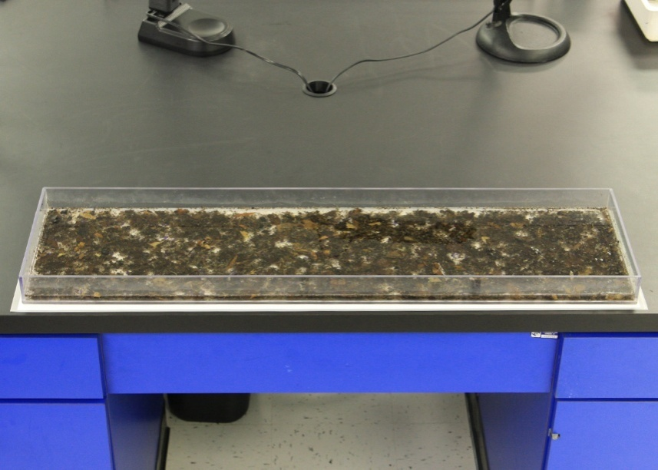Place the contents of the sieve in the gridded sorting tray. Fill the tray 1/3 full with water and gently swirl it until the contents are evenly distributed (***See Figure 54***). If the sample was divided into more than one jar, wash the contents of the additional sample jars and combine them with the first jar’s contents in the sorting tray at this point.

Figure 13. Photograph of a Gridded Sorting Tray with sample contents evenly distributed in water.

1. 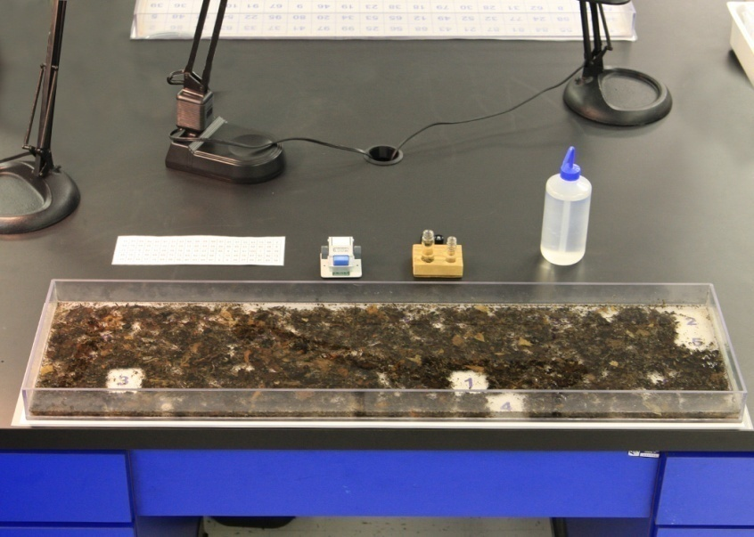Using a random number generator, select the first grid to be picked (***see Figure 55***). Using the "cookie cutter", isolate the organisms within the chosen grid and scoop the contents of the grid into a white enamel pan with just enough water in the bottom to easily maneuver the organisms. Be careful not to destroy any organisms during this step. Organisms with their head inside the grid are to be included within the grid. If you can't distinguish which end is the head, then the organism belongs in the grid that contains the largest portion of the body.

Figure 14. Photograph of a Gridded Sorting Tray with 5 grids randomly removed. Note that he sequence of numbers on the bottom of the tray known by referencing a piece of paper that has the locations of each grid mapped out.

1. Sorting (Picking)
   * + - 1. 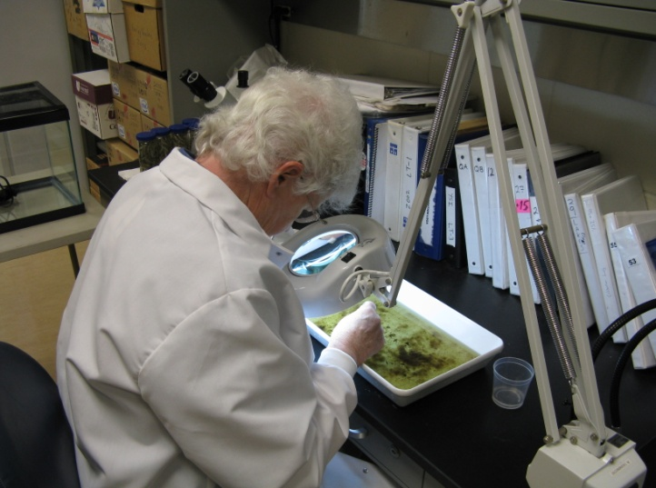Fill a crucible or temporary storage vial with 75% ethanol. If preferred, another small wide-mouth container may be substituted for the crucible.

Note: A small piece of tape, rolled into a ring so the adhesive is exposed, may be attached to the bottom of the crucible to prevent tipping.

* + - * 1. Using fine-tipped forceps and illuminated magnifier or magni-visor (***see Figure 56***), remove all invertebrates from the sub-sample and transfer to the alcohol filled crucible or labeled storage vial. Keep track of the number of organisms that have been picked.

Figure 15. Photograph of Biologist sorting a benthic sample under an illuminated magnifier. Note the enamel pan filled with some water and the temporary sample container.

* + - * 1. If leaves are present, be sure to examine both surfaces. Examine the debris for unusual clumps of twigs, leaves, or sand, which may be protective cases for some organisms. If cases are found, both the case and the organism should be picked. If the organism is in the case, the case and organism should be kept together. If an empty case is found, it should also be removed, but not counted towards the final number of organisms picked.
        2. If there is any doubt to the identity of an object (is it a seed or a bug?), it should be picked, but not counted. A senior biologist should be notified if a large number of questionable objects are present.
        3. When all the organisms appear to have been removed from the pan, agitate the contents of the pan and look again. Often the agitation will reorient an organism that was previously overlooked.
        4. Have a senior biologist inspect the pan after picking has been completed. The biologist will point out any organisms that have been overlooked or misidentified as detritus. As the picker becomes more proficient at his/her task, this step will be reduced in frequency.
        5. Discard the contents of the enamel pan by pouring the contents through a "waste sieve" in the sink. The contents of the waste sieve may be emptied into the trash as necessary.
        6. Continue the Sorting process repeatedly (steps 4-f through 5-e) until a subsample of 200 (+/- 20% is reached) (***see Figure 55 above***). Several rules must be observed in order to get a subsample that is both random and representative of the whole sample.

1. The total organisms in the sample must be between 160 and 240 organisms. If fewer than 160 organisms have been collected, another grid is randomly chosen and steps 4-f through 5-e are repeated until at least 160 organisms are obtained or until the entire sample has been picked. Every attempt should be made to get the final subsample as close to 200 as possible. Therefore, the person conducting the sub-sampling should keep track of the approximate number or organisms per grid in order to know if one more grid will get the subsample number as close to 200 as possible.
2. If subsampling should result in significantly more than 240 organisms in the subsample, then the subsample should be re-subsampled to bring the number of organisms down to the 200 (+/- 20%) organism goal.
3. Should the 200 (+/- 20%) organism goal be reached in less than 4 grids, then picking should continue until 4 total grids have been picked and then that subsample should be re-subsampled to reach the 200 (+/- 20%) organism goal. This step will ensure representativeness of the subsample compared to the total sample.

***For further information about subsampling rules, refer to the EPA Rapid Bioassessment Protocol References listed in*** *Error! Reference source not found.****.*** *Error! Reference source not found.****.*** *Error! Reference source not found.***Error! Reference source not found.Error! Reference source not found. *starting on page*** *Error! Bookmark not defined.*.

**Note: Based on WVDEP’s experience, >90% of the time, 4 or more grids out of 100 will need to be picked in order to reach the target 200 organism subsample for a 1m2 kick area.**

* + - * 1. Place the label made earlier inside the bottle/vial(s). If a second label is prepared for the outside of the bottle/vial, then affix it using tape. Be sure to write down the # of grids picked, # of organisms in final subsample, and if applicable, the Bottle/Vial # out of the Total Bottles/Vials for the subsample before you place the label inside the bottle/vial(s)
        2. Pour the subsample contents of the crucible (or temporary container) into the final storage bottle/vial(s). Use a squirt bottle containing alcohol to rinse the organisms from the crucible. Make sure that all organisms in the bottle/vial are fully submerged in the alcohol and that none are clinging to the sides of the bottle. Use the squirt bottle to rinse the sides of the bottle/vial, if necessary.
        3. If required, return the remainder of the unpicked sample to the original sample jar and preserve with alcohol. These samples may be processed later to determine picking efficiency.
        4. After a sample has been picked, record the date or return and your initials in the Benthic Macroinvertebrate Sample Logbook to indicate that the sample was returned from processing. Be sure that the sample information (*e.g*., date of collection, collector, stream name, county, AN-Code, # of bottle/vial(s), etc.) on the bottle/vial(s) matches the Benthic Macroinvertebrate Sample Logbook.

### Benthic Laboratory Processing Quality Assurance/Quality Control

Sorting efficiency is evaluated for 5% of the samples. These samples are randomly selected after they are received by the laboratory, but before they are sent to the pickers. Pickers conduct processing of the sample as normal, but each time they are done picking a subsample grid in the enamel pan, a second picker (usually a senior biologist) will review the pan for any missed organisms. The missed organisms for the entire sample are totaled.

#### Percent Sorting Efficiency (PSE)

The Percent Sorting Efficiency (PSE) (AKA Bias) can then be calculated by the following formula:

Equation 1. Percent Sorting Efficiency (PSE)

$$\frac{\# Organisms Originally Sorted}{\# Organisms Recovered by Checker+\# Organisms Originally Sorted}=PSE$$

A PSE >= 90% is considered passing.

Pickers may also be instructed to retain the unpicked portion. The unpicked portion can then be checked by a senior biologist to determine if the number of grids that need to be picked to get a second subsample is comparable to the original pick. This will indicate if the sample was evenly distributed in the tray.

## Identification of Benthic Macroinvertebrates

Ultimately, the WAB uses benthic macroinvertebrates to bioassess the condition of wadeable streams in WV. To accomplish this, the WAB uses a multi-metric index called the West Virginia Stream Condition Index (WVSCI). The WVSCI summarizes six biological metrics that represent elements of the structure and function of benthic macroinvertebrate communities. Taxonomic resolution for the WVSCI is family level except for Nematoda and Collembola. However, all taxa should be identified to the genus level or lowest practical taxon. All aquatic macroinvertebrates should be identified including insects, snails, clams, crustaceans (including crayfish), and worms.

### Materials and Supplies

1. Dissecting microscope - for examination of gross features.
2. Compound microscope - for examining minute features.
3. Fine-tipped forceps - for manipulating specimens.
4. Fine-tipped probes - for manipulating specimens.
5. Petri dishes - hold specimens during identification.
6. Alcohol - 75% ethanol is used to preserve the samples and to prevent desiccation during identification.
7. Wash bottle - used for alcohol storage.
8. Microscope slides, cover slips, and mounting media - for examination of tiny specimens and/or body parts under a compound microscope.
9. Benthic macroinvertebrate lab sheet - standard for recording results of identification and enumeration (***see Figure 16 below on page 180***).
10. Taxonomic Keys - (***see List of Taxonomic References below***)

### List of Taxonomic References

The taxonomic references most frequently used by the WAB biologists for identification of macroinvertebrates include, but are not limited to:

Brigham, A.R. 1982a. Coleoptera. *In* Brigham, A.R., W.U. Brigham, and A. Gnilka *(editors).* Aquatic Insects and Oligochaetes of North and South Carolina. Midwest Aquatic Enterprises. Mahomet, IL.

Brigham, A.R. 1982b. Megaloptera. *In* Brigham, A.R., W.U. Brigham, and A. Gnilka *(editors).* Aquatic Insects and Oligochaetes of North and South Carolina. Midwest Aquatic Enterprises. Mahomet, IL.

Brown, H.P. 1972. Aquatic Dryopoid Beetles (Coleoptera) of the United States. U. S. Government Printing Office.

Burch, J.B. 1982. Freshwater Snails (Mollusca: Gastropoda) of North America. EPA-600-3-82-026.

Edmunds, G.F., Jr., S.L. Jensen, and L. Berner. 1976. Mayflies of North and Central America. University of Minnesota Press.

Epler, J.H. 1995. Identification Manual for the Larval Chironomidae (Diptera) of Florida. Revised Edition. Florida Department of Environmental Protection, Division of Water Facilities, Tallahassee, Florida.

Epler, J.H. 1996. Identification Manual for the Water Beetles of Florida (Coleoptera: Dryopidae, Dytiscidae, Elmidae, Gyrinidae, Haliplidae, Hydraenidae, Hydrophilidae, Noteridae, Psephenidae, Ptilodactylidae, Scirtidae). Florida Department of Environmental Protection, Division of Water Facilities, Tallahassee, Florida.

Epler, J.H. 2001. Identification Manual for the Larval Chironomidae (Diptera) of North and South Carolina. North Carolina Department of Environmental and Natural Resources, Division of Water Quality, Raleigh, North Carolina.

Huggins, D.G. and W.U. Brigham. 1982. Odonata. *In* Brigham, A.R., W.U. Brigham, and A. Gnilka *(editors).* Aquatic Insects and Oligochaetes of North and South Carolina. Midwest Aquatic Enterprises. Mahomet, IL.

Jezerinac, R.F., G.W. Stocker, and D.C. Tarter. 1995. The Crayfishes (Decapoda: Cambaridae) of West Virginia. Ohio Biological Survey Bulletin. New Series. Vol. 10, No.1.

Lugo-Ortiz, C.R., and W.P. McCafferty. 1998. A New North American Genus of Baetidae (Ephemeroptera) and Key to *Baetis* Complex Genera. *Entomological News* **109**: 345-353.

Merritt, R.W., and K.W. Cummins *(editors).* 1995. An Introduction to the Aquatic Insects of North America. 3rd edition. Kendall/Hunt Publishing Company, Dubuque, Iowa.

Merritt, R.W., K.W. Cummins, and M.B. Berg *(editors).* 2008. An Introduction to the Aquatic Insects of North America. 4th edition/revised edition. Kendall/Hunt Publishing Company, Dubuque, Iowa.

Peckarsky, B.L., P.R. Fraissinet, M.A. Penton, and D.J. Conklin, Jr. 1990. Freshwater Macroinvertebrates of Northeastern North America. Cornell University Press, Ithaca, New York.

Pennack, R.W. 1978. Fresh‑water Invertebrates of the United States. 2nd edition. John Wiley & Sons, New York.

Ross, H.H. 1944. The Caddisflies, or Trichoptera, of Illinois. *Bulletin of the Illinois Natural History Survey* **23**: 1‑326.

Smith, D.G. 2001. Pennak’s Freshwater Invertebrates of the United States: Porifera to Crustacea. 4th edition. John Wiley & Sons, New York.

Stewart, K.W. and B.P. Stark. 1988. Nymphs of North American Stonefly Genera (Plecoptera). Entomological Society of America.

Unzicker, J.D. and P.H. Carlson. 1982. Ephemeroptera. *In* Brigham, A.R., W.U. Brigham, and A. Gnilka *(editors).* Aquatic Insects and Oligochaetes of North and South Carolina. Midwest Aquatic Enterprises. Mahomet, IL.

Unzicker, J.D. and V.H. McCaskill. 1982. Plecoptera. *In* Brigham, A.R., W.U. Brigham, and A. Gnilka *(editors).* Aquatic Insects and Oligochaetes of North and South Carolina. Midwest Aquatic Enterprises. Mahomet, IL.

Unzicker, J.D.; V.H. Resh; and J. C. Morse. 1982. Trichoptera. *In* Brigham, A.R., W.U. Brigham, and A. Gnilka *(editors).* Aquatic Insects and Oligochaetes of North and South Carolina. Midwest Aquatic Enterprises. Mahomet, IL.

Wiggins, G.B. 1977. Larvae of the North American Caddisfly Genera (Trichoptera). University of Toronto Press, Toronto, Canada.

Wiggins, G.B. 1996. Larvae of the North American Caddisfly Genera (Trichoptera). 2nd edition. University of Toronto Press, Toronto, Canada.

White, D.S. 1982. Elmidae. *In* Brigham, A.R., W.U. Brigham, and A. Gnilka *(editors).* Aquatic Insects and Oligochaetes of North and South Carolina. Midwest Aquatic Enterprises. Mahomet, IL.

### Safety Precautions

Protective eyewear should be worn during sample identification to prevent contact with the residual alcohol in the specimens and debris or at any time while handling alcohol, which can be a skin irritant and can cause damage to the eyes. All sample identification should occur in a well ventilated area to reduce inhalation of alcohol fumes.

### Macroinvertebrate Identification Procedures

1. Check out the sample in the Benthic Macroinvertebrate Sample Logbook. The laboratory manager may pre-assign which taxonomist gets which sample and if that sample will be subject to a QA check. Be sure that the sample information (*e.g*., date of collection, collector, stream name, county, AN-Code, # of bottle/vial(s), etc.) on the vial matches the Benthic Macroinvertebrate Sample Logbook. Also mark the sign-out date for identification and your initials in the logbook.
2. Complete the top portion of a "Benthic Macroinvertebrate Lab Sheet" with the sample information (*e.g*., date of collection, collector, stream name, county, AN-Code, etc.) (***see Figure 16 bel*ow**).
3. Using the taxonomic keys listed above (***see List of Taxonomic References above***); identify the contents of the sample to the family or genus level, depending on the specifications of the project. Use the reference collection as additional confirmation, if necessary. **IF YOU HAVE ANY UNCERTAINTY ABOUT THE IDENTIFICATION OF A SPECIMEN, CONSULT A FELLOW BIOLOGIST FOR CONFIRMATION.** If an organism is too small or damaged and cannot be identified to the designated taxonomic level, identify it to the lowest positively-identified taxon and document why the identification was not complete (*e.g*., immature or damaged specimens).
4. Record results of the identification and enumeration on a "Benthic Macroinvertebrate Lab Sheet" (***see Figure 16 bel*ow**). Be sure to include notes for each taxa about immature or damaged specimens, life stages other than larvae (*i.e*., Adults and Pupae), terrestrial specimens that were picked inadvertently, numbers of specimens pulled for reference collections, and likely characters that would place the specimen in a lower level taxon if you are unfamiliar with the organism.



**Figure 16. Example of a Benthic Macroinvertebrate Lab Sheet.**

1. Return the specimens to the original sample bottle and mark the label with an "X" to indicate the sample has been identified.
2. Return the identified sample bottle/vial(s) and corresponding lab sheet. Be sure that the sample information (*e.g*., date of collection, collector, stream name, county, AN-Code, # of bottle/vial(s), etc.) on the vial matches the Benthic Macroinvertebrate Sample Logbook. Also mark the date of return from identification and your initials in the logbook.

### Benthic Laboratory Identification Quality Assurance/Quality Control

The precision of the identification process is evaluated for at least 5% of the samples. The samples are randomly selected after they are received by the laboratory and picked, but before they are sent to the taxonomists. A proper sample for identification QA/QC must have a total count that falls within the 200 +/- 20% subsample size (*i.e.*, samples with counts below 160 should not be selected). Taxonomists conduct the identification and enumeration of the sample as normal. After they are done, if the sample is designated for a QA/QC check, then all of the specimens (mounted or loose) are passed on to the second taxonomist. The second taxonomist will identify and enumerate the sample in the same fashion as the first.

From these two sets of data, several evaluations of precision can be calculated:

#### Percent Difference in Enumeration (PDE)

The Percent Difference in Enumeration (PDE) is calculated by the following formula:

Equation 2. Percent Difference in Enumeration (PDE)

$$\frac{(n_{1}-n_{2})}{(n_{1}+n_{2})}×100=PDE$$

Where:

n1 = # of organisms counted by taxonomist 1

n2 = # of organisms counted by taxonomist 2

A PDE <=10% is considered passing.

#### Percent Taxonomic Difference (PTD)

Percent Taxonomic Difference is a comparison of the accuracy in identifications from one taxonomist to another. This begins thru the use of a Taxonomic Comparison Form. On this form, the identifications by both taxonomists are matched up to each other and then difference in enumerations between the two taxonomists is compared. The number of agreements is defined as the lower of the two numbers for the given taxon being compared.

The Percent Taxonomic Difference (PTD) is calculated by the following formula:

Equation 3. Percent Taxonomic Difference (PTD)

$$\left[1-\frac{\left({comp}_{pos}\right)}{\left(N\right)}\right]×100=PTD$$

Where:

N= Highest count of organisms from taxonomist 1or 2

comppos = Total # of taxonomic agreements from the Taxonomic Comparison Form

A PTD <=10% is considered passing for Family Level taxonomy.

A PTD <=15% is considered passing for Genus Level taxonomy.

PTD is not an evaluation of which taxonomist is correct. However, the process does include a method by which conflicts in taxonomic identification are reconciled. After the PTD is calculated, both taxonomists and a third party sit down and attempt to ascertain where the differences in identifications and enumerations are coming from. Reasons for the differences include:

1. **Misidentification of the Taxon**.
2. One of the taxonomists may not be as familiar with a particular taxon as the other and keyed it wrong. This may be a consistent error in all of the QA samples involving the taxonomists.
3. One taxonomist is using an outdated key that refers to a taxon that has been lumped with or is synonymous with another taxon.
4. One of the taxonomists accidentally included a terrestrial specimen from a taxon that is very similar to an aquatic taxon.
5. **Taxonomic Resolution**.
6. The first taxonomist may have inadvertently damaged a key feature of a specimen that prevented it from being identified by the second taxonomist to the same taxonomic level.
7. One of the taxonomists may be better experienced and familiar with that particular taxon and be able to identify it the lower taxonomic level where the other taxonomist cannot.
8. **Specimens Lost Between Taxonomists**. This should be kept to a minimum if the two taxonomists view the sample before it is put back into the bottle/vial(s).
9. Specimens may have been pulled from the sample (*e.g*., Reference Collection or Slide Mounting) and not viewed by the second taxonomist.
10. Specimens stuck to the bodies of larger organisms (*e.g*., an Elmidae beetle stuck in the “armpit” of a large *Corydalus* specimen) are missed by one taxonomist.
11. One taxonomist was including pupae, body parts, or empty shells/cases in the count while the other was not.
12. One taxonomist may have counted partial organisms as whole organisms. This is most common with Oligochaeta as the head are difficult to find and they often get broken up into pieces easily.
13. **Transcription, Translation, and Typographic (TTT) Errors**.
14. One taxonomist meant to write down an 11 and accidentally wrote down a 1.
15. The person who calculated the PTD mistook an 11 for a 2.
16. The taxonomist wrote down a very similarly spelled taxon (*e.g*., *Thienemannimyia* vs. *Thienemanniella* vs. *Thienemannia*)

After this reconciliation, the PTD can be recalculated correcting for these most of these errors (called a corrected PTD).

#### Comparision of Index Result (CIR)

Comparison of Index Result is a simple comparison of how the identification differences between taxonomists would affect the IBI score(s) and final impairment decision. To do this you would simply calculate the sample IBI score from each taxonomist’s identification independently and then get the absolute value of the differences. Each IBI score can then be translated into the appropriate IBI narrative category (e.g., Unimpaired vs. Impaired, Unimpaired-Very Good vs. Unimpaired-Good, Slightly Impaired vs. Moderately Impaired) to see if the differences in identification between taxonomists result in conflicting decisions about the level of impairment. The absolute value of the differences of IBI scores can help qualify the extent of disagreement, especially when the IBI scores straddle a category threshold.

## Benthic Macroinvertebrate Data Analysis

### West Virginia Stream Condition Index (WVSCI)

#### WVSCI Reference

A detailed description of the procedures used to develop the WVSCI as well as the steps necessary to calculate final WVSCI scores can be found in the following document:

Gerritson, J., J. Burton, and M.T. Barbour. 2000. *A Stream Condition Index for West Virginia Wadeable Streams.* Tetra Tech, Inc. Owing Mills, MD.

Or on the web at:

[http://www.dep.wv.gov/WWE/watershed/bio_fish/Documents/WVSCI.pdf](https://dep.wv.gov/WWE/watershed/bio_fish/Documents/WVSCI.pdf)

and an addendum document at:

[*http://www.dep.wv.gov/WWE/watershed/bio_fish/Documents/WVSCI Addendum.doc*](https://dep.wv.gov/WWE/watershed/bio_fish/Documents/WVSCI%20Addendum.doc)

#### WVSCI Overview

All organisms identified for analysis using the WVSCI (including all Oligochaeta, Hirudinea, Acari, Mollusca, and Crustacea) should be identified to at least the Family level except for Nematoda and Collembola.

The following metrics are applied to the benthic data:

Family Level Taxa Richness

Family Level Ephemeroptera, Plecoptera, Trichoptera (EPT) Taxa Richness

Percent EPT

Percent Contribution of Dominant 2 Family Level Taxa

Percent Chironomidae

Modified Family Level HBI (Hilsenhoff’s Biotic Index)

The individual metric scores are then standardized on a 100 point scale based on best standard values for a set of reference sites or conditions. The scores are then averaged to give the WVSCI (West Virginia Stream Condition Index).

#### Restrictions for Calculating the WVSCI

1. Sample methodology – Identical sampling area (4 – 0.25m2) and gear (0.5 m rectangular kicknet with a **595-600 μm mesh**) should be used in **riffle/run habitat**. In limited circumstances, 0.3 m d-frame nets with comparable mesh size can be used as long as **1 m2 total area** is sampled.
2. Comparable samples – The following scenarios should be considered before collecting benthic macroinvertebrate samples for biological health assessments because they are not necessarily associated with human perturbations:
   * + 1. **low flow** conditions in riffle/runs may affect benthic sampling efficiency by reducing the number of organisms being swept into the net,
       2. collecting samples following **drought** may result in reduced organism numbers and diversity,
       3. **high flow** conditions in riffle/runs may affect benthic sampling efficiency by reducing the number of organisms being captured in the net,
       4. collecting samples following a **scour or flood event** may result in reduced organism numbers and diversity.

1. Laboratory subsampling – samples in which more than the target subsample size was picked **(200 ±20%)** should be re-sorted to obtain the preferred number of organisms. **As a rule-of thumb, samples containing less than 100 organisms should be scrutinized for comparability before calculating a WVSCI score.** These sites may be heavily impacted, or were recently subjected to drought or scour events.
2. Taxonomic resolution – Taxonomic resolution for the WVSCI is **family level except for Nematoda and Collembola. This includes the non-insect groups like Oligochaeta, Hirudinea, Acari, Mollusca, and Crustacea.** If higher taxonomy is necessary (*e.g*., early instar or damaged specimens), then these taxa should not be counted in richness metrics unless they are believed to be distinct from other taxa identified in the sample. WVDEP WAB should be consulted for exact taxonomic resolution of some groups.
3. Seasonality – Acceptable collection dates are from **April 15 to October 15**.
4. Tolerance values – WVSCI metrics that rely on **tolerance values** (HBI) are **specifically calibrated** to those used by WAB and these specific tolerance values should be used for valid final WVSCI scores.
5. WVSCI Calculations — Use only those best standard values (BSVs) and component metrics found in the WVSCI development document. Component metrics used for calculating WVSCI scores are restricted to those listed above. **Exclusion of any one of these metrics or the inclusion of additional metrics will result in an invalid final WVSCI score.**

#### Using the WVSCI for Data Analysis

Macroinvertebrate data is evaluated through the preparation of a stream assessment chart (***see below***). This chart considers the biological and habitat conditions of each stream and compares them to those of the reference sites. Reference sites are those stations having optimal habitat (as defined by the RBP/EMAP matrix scores) and no obvious impairments in water quality. The number of reference sites selected depends on such variables as stream order and ecoregions. The framework for these assessments is the West Virginia Stream Characterization Index (WVSCI). Tetra Tech, Inc. developed this index specifically for use in West Virginia. Stream scores are plotted within this chart and the results are used for overall watershed assessments, 305(b) reporting and 303(d) listing. Streams falling in the green area are considered fully supporting (for 305(b) reporting) or non-impaired (for WAB reporting). The condition of streams in the gray area may be unclear and are considered “Insufficient Data” (305(b)) and non-impaired (for WAB reporting). Water quality data must be evaluated to determine if a stream in the gray area is threatened or fully supporting. Often best professional judgment cannot be avoided. The yellow, orange, and red areas contain streams that are not supporting (305(b)) or impaired (WAB reporting). All streams falling in the yellow, orange and red sections are subject to inclusion on the 303(d) list.

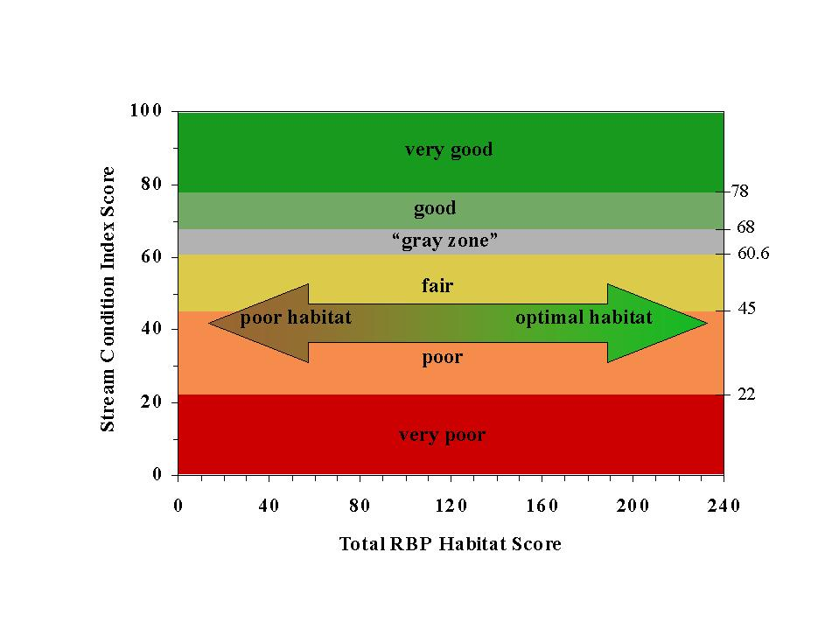

Figure 17. WVSCI vs. RBP Habitat Scoring Categories

### Dirty Null Stressor Identification Model

The benthic data is also imported into an analysis model that compares each sample’s community structure to that a set of “reference” data with well known and established stressor types (Metals, Sediment, Ionic Stress, and Reference Condition), also known as “Dirty Nulls”. The data that results from the Dirty Null Stressor Identification Model is a set of similarity indexes and probability percentages that help identify potential stressor or stressors to the stream community